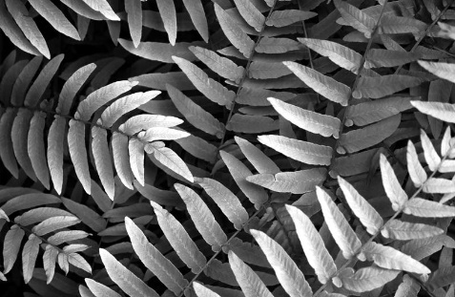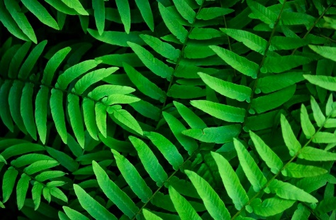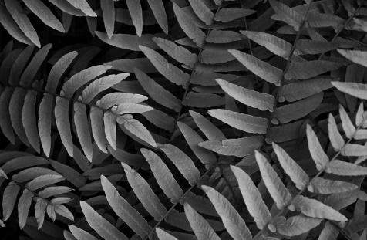**Contrast**

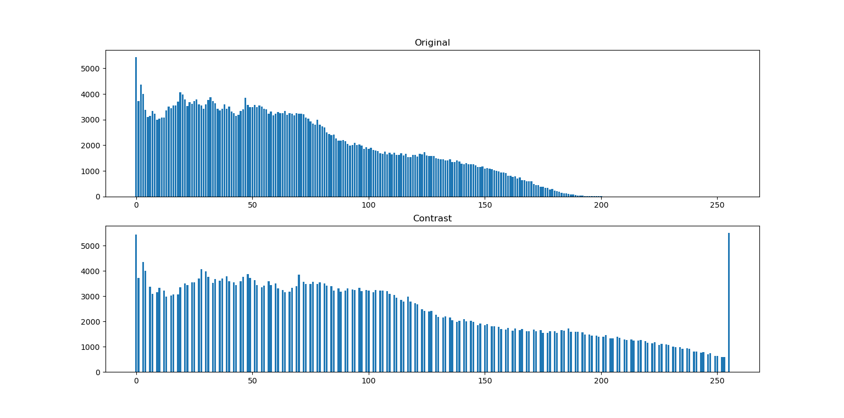**Fig.** 1 Original  **Fig.** 2 Gray scale image **Fig.** 3 Adjust contrast image

gap

**Fig.** 4 Compare histogram of original image and adjust contrast image

From Fig. 4 shown that the adjust contrast image is saturation, it has more range of intensity that mean it is high contrast, it has gap.

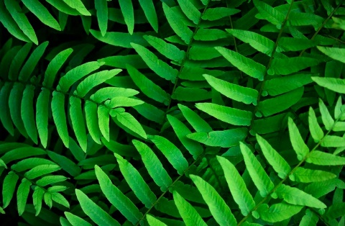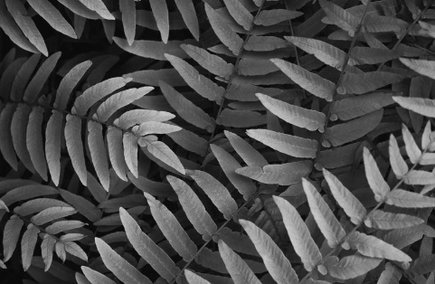**Brightness**



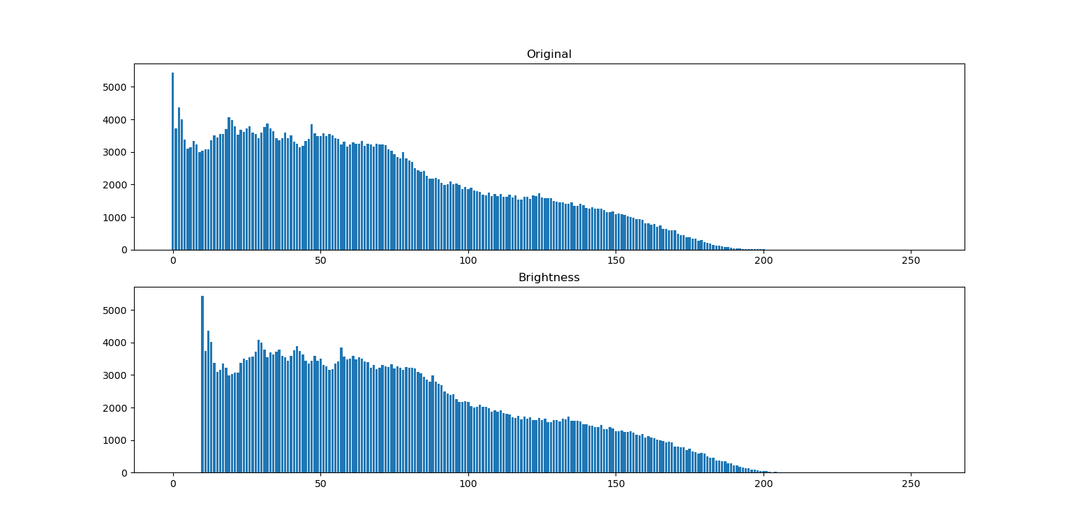**Fig.** 5 Original **Fig.** 6 Gray scale image  **Fig.** 7 Adjust brightness image

**Fig.** 8 Compare histogram of original image and adjust brightness image

From Fig. 8 shown that the adjust brightness image has same range of intensity as original image and the histogram of adjust brightness image is shift from original image that mean brightness image is brighter than original image.

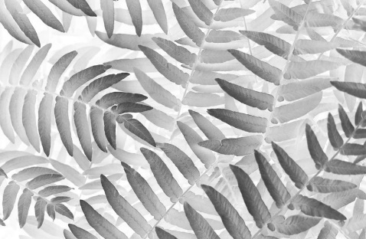**Inverse**

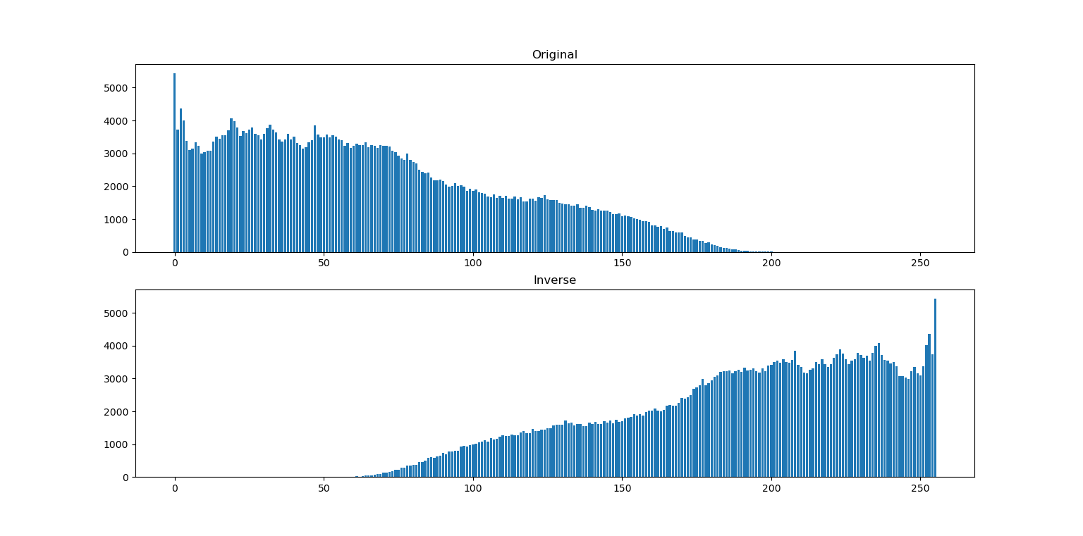 **Fig.** 9 Original **Fig.** 10 Gray scale image  **Fig.** 11 Inverse image

**Fig.** 12 Compare histogram of original image and inverse image

From Fig. 12 shown that the histogram of inverse image is reverse from histogram of original image that mean color of image is transfer black to white, white to black

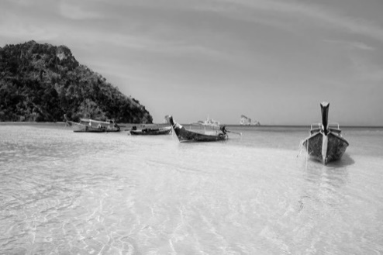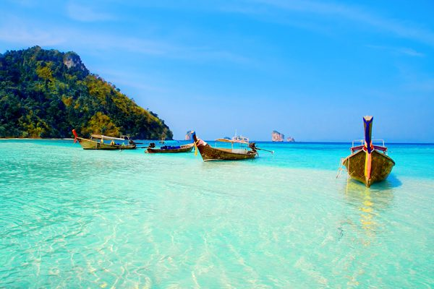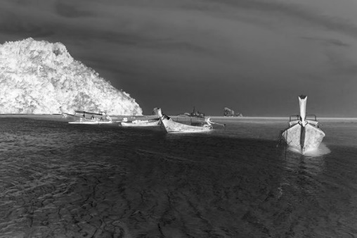

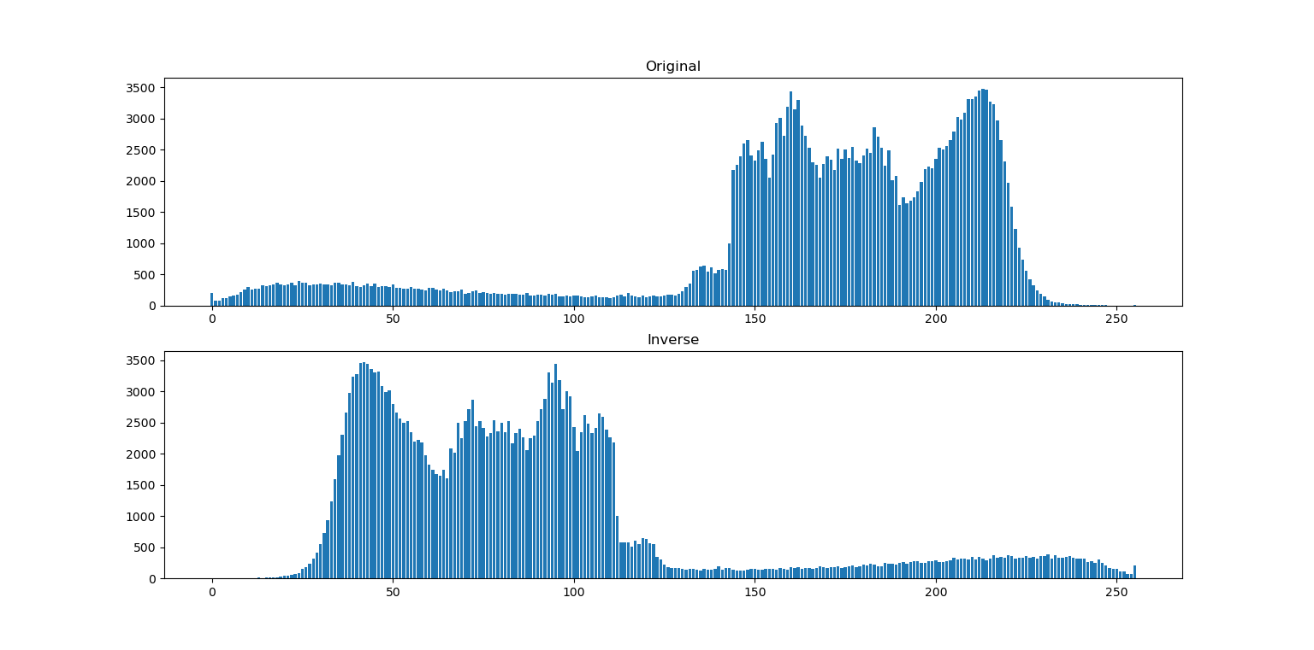**Fig.** 13 Original **Fig.** 14 Gray scale image  **Fig.** 15 Inverse image

**Fig.** 16 Compare histogram of original image and inverse image

From Fig. 16 shown that the histogram of inverse image is reverse from histogram of original image that mean color of image is transfer black to white, white to black